Total Orders
SELECT COUNT(DISTINCT order_id) AS total_orders FROM warehouse.fact_orders;
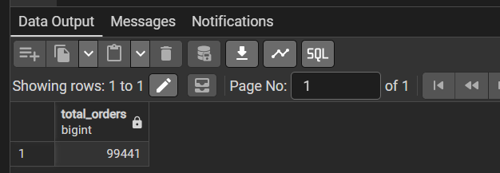
Total product sales
SELECT ROUND(SUM(price), 2) AS total_product_sales FROM warehouse.fact_order_items;
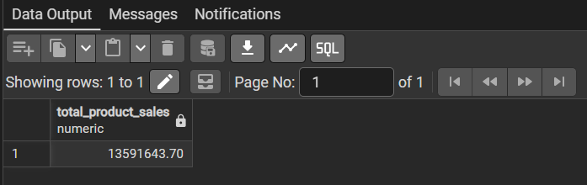
Total delayed Orders
SELECT COUNT(*) AS delayed_orders FROM warehouse.fact_orders WHERE delivery_status = 'Delayed';
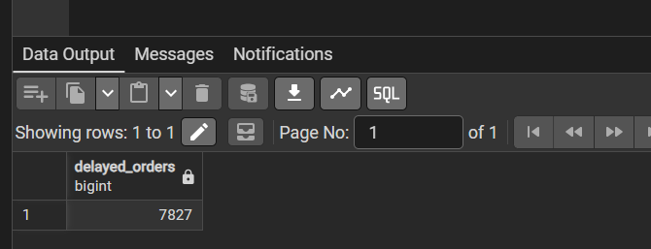
On-time delivery percentage
SELECT COUNT(*) FILTER ( WHERE delivery_status = 'On Time' ) AS on_time_orders, COUNT(*) FILTER ( WHERE delivery_status = 'Delayed' ) AS delayed_orders, ROUND( 100.0 * COUNT(*) FILTER WHERE delivery_status = 'On Time' ) / NULLIF( COUNT(*) FILTER ( WHERE delivery_status IN ('On Time', 'Delayed') ), 0 ), 2 ) AS on_time_percentage FROM warehouse.fact_orders;
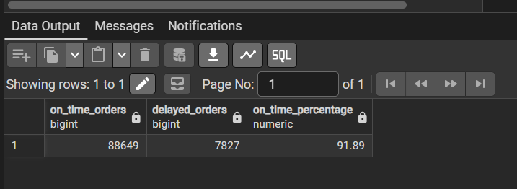
Delays by customer state
SELECT
c.customer_state,
COUNT(*) AS total_delayed_orders,
ROUND(AVG(o.actual_delivery_days), 2)
AS avg_delivery_days
FROM warehouse.fact_orders o
JOIN warehouse.dim_customers c
ON o.customer_key = c.customer_key
WHERE o.delivery_status = 'Delayed'
GROUP BY c.customer_state
ORDER BY total_delayed_orders DESC;
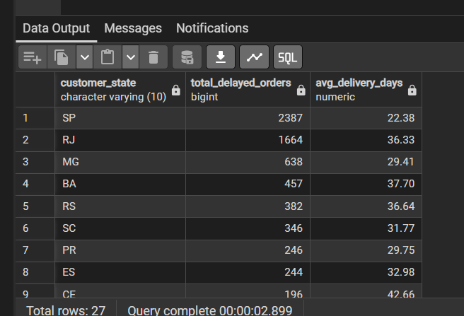
Delays by seller
SELECT
s.seller_id,
s.seller_state,
COUNT(DISTINCT oi.order_id) AS total_orders,
COUNT(DISTINCT oi.order_id) FILTER (
WHERE o.delivery_status = 'Delayed'
) AS delayed_orders
FROM warehouse.fact_order_items oi
JOIN warehouse.fact_orders o
ON oi.order_id = o.order_id
JOIN warehouse.dim_sellers s
ON oi.seller_key = s.seller_key
GROUP BY s.seller_id, s.seller_state
HAVING COUNT(DISTINCT oi.order_id) >= 5
ORDER BY delayed_orders DESC;
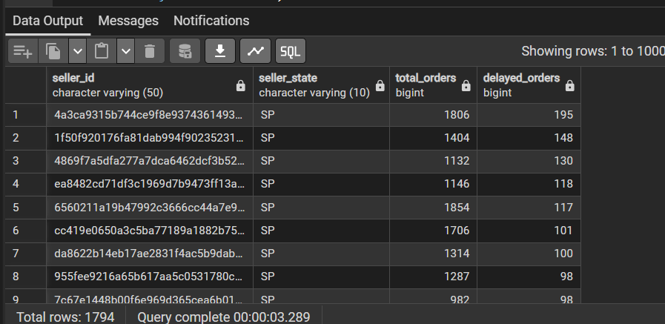
Average delivery time by order status
SELECT
order_status,
COUNT(*) AS total_orders,
ROUND(AVG(actual_delivery_days), 2)
AS avg_delivery_days
FROM warehouse.fact_orders
WHERE actual_delivery_days IS NOT NULL
GROUP BY order_status
ORDER BY avg_delivery_days DESC;
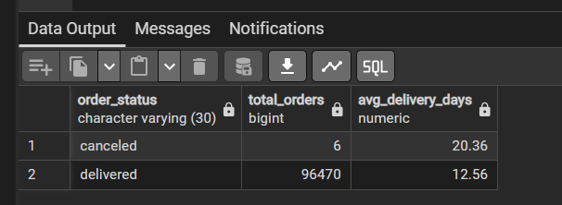

Prepare business recommendations
Convert your findings into business recommendations. For example:
Business problem | Potential recommendation
High delay percentage in a state | Review logistics performance in that region
Sellers with high delay rates | Introduce seller performance monitoring
Long delivery duration | Investigate carrier handover and transit stages
Low customer review scores | Investigate delivery and product-related complaints
These are hypotheses to investigate, not conclusions. Use your actual query results to support each recommendation.

Build an Excel-Based Supply Operations Report
Step 1 : Export shipment data from PostgreSQL
Open pgAdmin and run this query:

SELECT
o.order_id,
c.customer_state,
o.order_status,
o.order_purchase_timestamp,
o.order_approved_at,
o.order_delivered_carrier_date,
o.order_delivered_customer_date,
o.order_estimated_delivery_date,

ROUND(o.actual_delivery_days, 2)
AS actual_delivery_days,

ROUND(o.estimated_delivery_days, 2)
AS estimated_delivery_days,

o.delivery_status,
o.data_quality_status,

(
SELECT STRING_AGG(DISTINCT s.seller_state, ', ')
FROM warehouse.fact_order_items oi
JOIN warehouse.dim_sellers s
ON oi.seller_key = s.seller_key
WHERE oi.order_id = o.order_id
) AS seller_states,

(
SELECT COUNT(*)
FROM warehouse.fact_order_items oi
WHERE oi.order_id = o.order_id
) AS total_items

FROM warehouse.fact_orders o
LEFT JOIN warehouse.dim_customers c
ON o.customer_key = c.customer_key
ORDER BY o.order_purchase_timestamp;

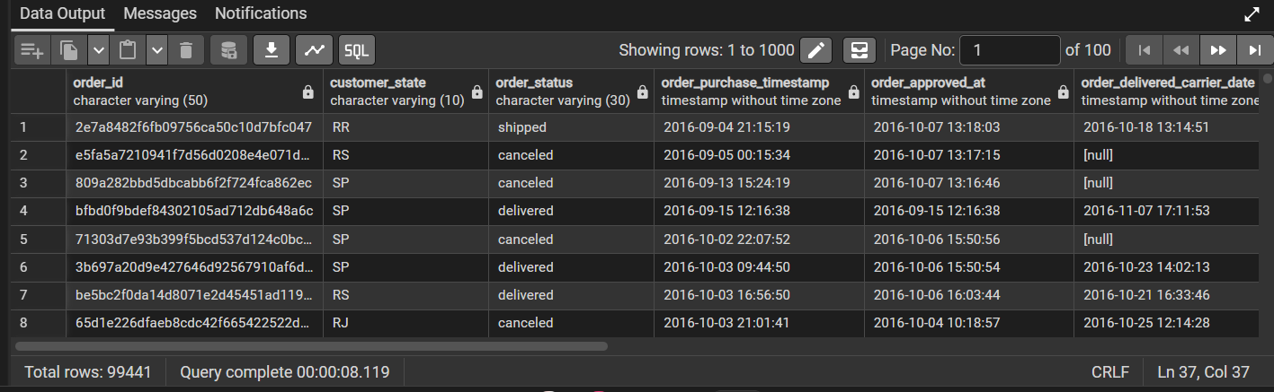

Step 2. Add operational tracking columns
Add these columns to the right of your imported data:
New column | Purpose
Delivery Variance | Actual days minus estimated days
Delay Days | Number of days late
SLA Status | On Time / Delayed / Pending
Delivery Stage | Delivered / In Transit / Not Shipped
Delay Category | Delay classification
Use the following formulas.
A. Delivery Variance
=IF([@actual_delivery_days]="","",[@actual_delivery_days]-[@estimated_delivery_days])

B. Delay Days
=IF([@order_delivered_customer_date]="","",MAX(0,INT([@order_delivered_customer_date])-INT([@order_estimated_delivery_date])))

C. SLA Status
=IF([@order_delivered_customer_date]="","Pending",IF([@order_delivered_customer_date]<=[@order_estimated_delivery_date],"On Time","Delayed"))

D. Delivery Stage
=IF([@order_delivered_customer_date]<>"","Delivered",IF([@order_delivered_carrier_date]<>"","In Transit",IF([@order_status]="canceled","Cancelled","Not Shipped")))

E. Delay Category
=IF([@[SLA Status]]="Pending","Pending",IF([@[Delay Days]]=0,"No Delay",IF([@[Delay Days]]<=3,"Minor Delay",IF([@[Delay Days]]<=7,"Moderate Delay","Severe Delay"))))

These are analytical classifications for your report, not official contractual SLA categories.

